Setting up the Development Environment
And Automatic Build Utilities
For the Tawala Desktop Applications
Updated 12/16/2008 11:14:00 PM

Overview
The development environment setup covers the steps to get up and running for accessing the source code for the Tawala desktop applications (and related tests suites), and to build them.

The Automated Build Environment is needed only if you will be generating release builds of the Designer application and its installer for distribution.

- Setting up the Development Environment

- Install and configure Visual Studio .NET 2008 and the MSDN Library

- Install and set up Tortoise SVN

- Check out all files from the SVN repository

- Install and set up TX Text Control .NET – Version 12.0, Service Pack 2

- Install and configure NUnit - Version 2.4.8

- Install Visual SVN

- Setting up the Automated Build Environment

- Install NAnt and NAntContrib Utilities

- Install Subversion

- Install WinZip Self Extractor

- Set the required PATH environment variable attributes

- Test run the NAnt automated build

- (Optional) Running the NAnt Build from within Visual Studio 2008

Visual Studio .NET 2008 Setup
Use the “Custom” installation, and select the following options (next three screen shots):

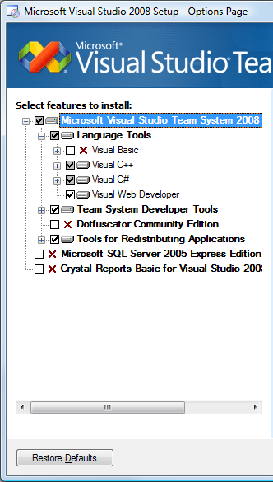
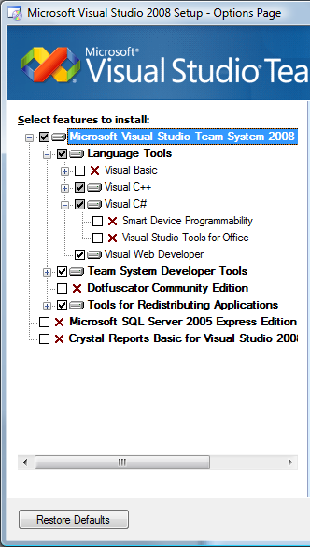
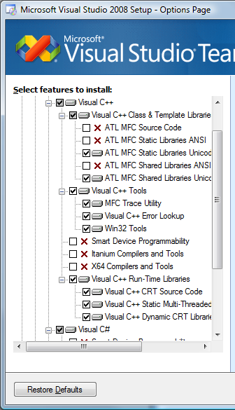

Installation of Visual C++ is not necessary, but I would at least install everything in the subsection called “Visual C++ Run-Time Libraries”.

MSDN Library Setup

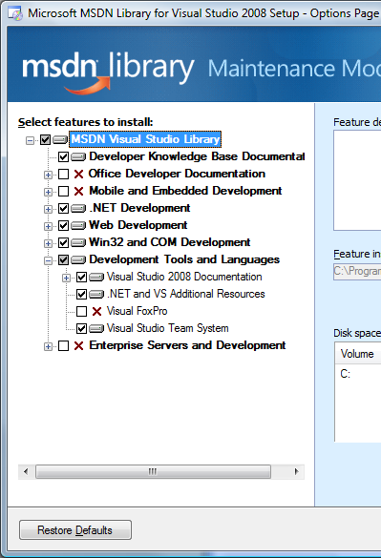

By doing a custom MSDN installation like above, you not only cut down on disk space used, but also reduce the amount of extraneous references / documentation.

TortoiseSVN Installation and Setup
TortoiseSVN is an extension of Windows Explorer. It adds additional menu items and icons to the files checked out from SVN. More details about it can be found at http://tortoisesvn.net/.

Installation
- Go to http://tortoisesvn.net/downloads and download the right file for your system. Typically it is a .msi file for 32-bit applications.
- Run the installation accepting all defaults.
- Restart your computer after install.

Preventing password prompts
There is an optional step that will help you avoid being asked for the password every time you work with SVN. The problem with this step is the fact that your server password will be stored in clear text somewhere on the file system. Use at your own risk.
- Open Windows Explorer
- Select any folder --> Right Click --> TortoiseSVN --> Settings
- Select "Network" node.
- In "SSH Client:" browse to the installed location of the TortoiseSVN Plink.exe file and type the following at the end “ –pw password” (replace “password” with your password at svn.tawala.com.). E.g.:
C:\Program Files\TortoiseSVN\bin\TortoisePlink.exe -pw password

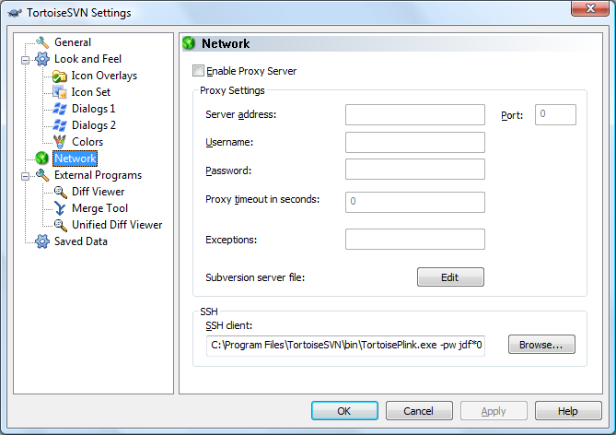

Check out all files from the SVN repository
In addition to source code, the SVN repository contains installers for third party libraries and other utilities required for the Development Environment and Automatic Build procedures.

- Create a folder on your system for the files. This will be your “Checkout directory”.
- Select that folder --> Right Click --> SVN Checkout
- Enter the following into the URL Repository box, replacing "username" with your user name on the Tawala server:
svn+ssh://username@svn.tawala.com/home/svn/repository/tawala_designer/trunk
- Make sure the folder in the Checkout directory box is the folder you have selected.

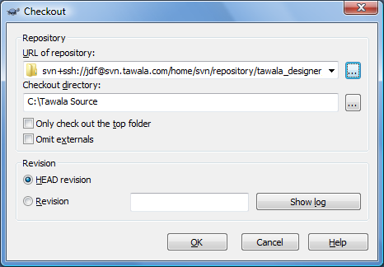

- Press the OK button. This will check out the entire file hierarchy from the repository to your Check out directiory.

TX Text Control .NET Installation
You should already have installed TortoiseSVN and done a recursive check-out of the entire Tawala repository. This will include the Utilities folder.

- Under the Utilities folder there is a TX Text Control folder. Run Setup.exe from that folder to install TX Text Control .NET Version 12.0 on your system. (Note: This installation includes Service Pack 2.)

As part of the installation you will be prompted for a serial number. The currently assigned serial numbers can be found in the _Developer Serial Numbers.txt file in the same folder.

- Important: After the installation is complete, find the following file under the installed TX folders:
Filename: txtextcontrol12.0.msm
Likely location: C:\Program Files\The Imaging Source Europe GmbH\TX Text Control 12.0.NET\MergeModule
Copy that file to: C:\ Program Files\Common Files\Merge Modules

NUnit Installation and Setup
You should already have installed TortoiseSVN and done a recursive check-out of the entire Tawala repository. This will include the Utilities folder.

- Uninstall any prior installations of NUnit using the Control Panel.
- Delete remnants of NUnit installations in the Program Files directory. Sometimes NUnit doesn’t uninstall completely.
- Under the Utilities folder there is a NUnit folder. Run NUnit-2.4.8-net-2.0.msi from that folder to install NUnit on your system.

After having built the TawalaTest solution, start NUnit 2.4.8. If all is well, the tests will load without error.

- Click the Tools | Options… menu item. Configure the Test Load tab of the NUnit Options dialog as shown below:

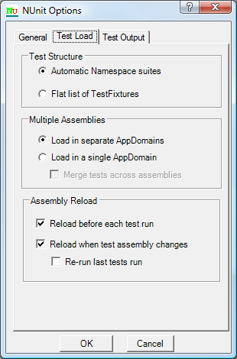

Notes about the NUnit setup:

- The Automatic Namespace suites setting is required so the [SetupFixture] attribute will work. This attribute allows a class to defined a namespace wide setup and teardown method that get executed only one time for all tests in the same namespace. This is useful for setting up Functions, for instance. This feature is being used in code checked in Sunday, August 26, 2007.

- The Load in separate AppDomains is necessary so that each Test Assembly should start with a “clean slate!”

This section isn’t required reading. However, if you want to have an inkling of why using this setting is a good idea, then proceed.

This setting is required so that tests in different assemblies have no chance of affecting each other. Otherwise static constructors are called only once and static variable are initialized only once during a test run. Test assemblies farther down the chain are left with whatever legacy that came before them depending on test execution order, etc. Who knows where or when this could subtly affect test results?

One current example involves Functions and the Document related factories, such as those in Paragraph.cs, that are initialized by static constructors. The problem is that Functions are also registered in those static constructors. Not all tests assemblies use the same, current version of the Function repository Xml. Some don’t need too for the type of tests they do. The Functions first registered by the static constructors in a test run win. If the next test assembly in the run rebuilds the Functions with different repository Xml, the factories in Paragraph.cs still have their prior values and are now out of sync.

It’s not really the responsibility of the app to support quirks of the test environment. So we must use Load in separate AppDomains.

VisualSVN Installation
VisualSVN provides integration of SVN into Visual Studio 2008, so that source files may be Updated from and Committed to the repository from within the IDE.

You should already have installed TortoiseSVN and done a recursive check-out of the entire Tawala repository. This will include the Utilities folder.

- Under the Utilities folder there is a VisualSVN folder, which should contain the latest version in use by the development team. Run the .msi installer file from that folder to install VisualSVN on your system, accepting all the default options.
- Open Visual Studio 2008 and verify that there is a VisualSVN menu item.

Note: The following are needed only if you will be doing automated release builds of the Designer application and its installer for distribution.

NAnt and NAntContrib Utilities
You should already have installed TortoiseSVN and done a recursive check-out of the entire Tawala repository. This will include the Utilities folder.

- Under the Utilities folder there is an NAnt folder. Extract the contents of NAnt.NAntContrib.zip to C:\Program Files.

Note: NAnt is a scripting engine for automating tasks in the .NET environment. NantContrib consists of third-party extensions to NAnt. These two packages are ordinarily distributed separately, but they have been combined into a single ZIP file here to eliminate some of the manual configuration steps.

Subversion Installation
You should already have installed TortoiseSVN and done a recursive check-out of the entire Tawala repository. This will include the Utilities folder.

- Under the Utilities folder there is a Subversion folder, which should contain the latest version in use by the development team. Run the Setup exe file from that folder to install Subversion on your system.

Note: The only item we actually need from the Subversion package is SVN.EXE, the Subversion command-line client. The NAntContrib tasks called <svn>, <svn-update> and <svn-checkout> require that executable in order to function.

WinZip Self Extractor Installation and Setup
You should already have installed TortoiseSVN and done a recursive check-out of the entire Tawala repository. This will include the Utilities folder.
- Under the Utilities folder there is a WinZip Self Extractor folder. Run winzipse22.exe from that folder to install WinZip Self Extractor on your system.
- Run WinZip Self Extractor. On the first screen of the Wizard panel, press the Enter Registration Code button, and enter the following in the dialog:
Registered to: Kevin Moore
Registration ID: 598870
- Close the WinZip Self Extractor Wizard.

PATH environment variable settings
Examine your system's PATH environment variable. If the following paths are not included, be sure to add them:
- C:\Program Files\Subversion\bin (or your equivalent)
- C:\Program Files\NAnt\bin (or your equivalent)
- C:\Program Files\NUnit 2.4.8\bin (or your equivalent)

Running the NAnt automated build
- Under the Build folder, double-click the Command Prompt icon to open the Command window.
- At the prompt type: nant cleanBuild
This should:
  - Check out all the source code files into a Code folder
  - Build the Tawala Test suit
  - Run all the tests
  - Build release versions of the Designer and Invitation Manager applications
  - Package the applications into a Tawala.msi installation file
  - Bundle the Tawala.msi and Setup.exe files into the self-extracting Tawala.exe file. That file will be found in the Build\Code\Tawala\Setup\Release folder.

Note that you may encounter the following error:
svn: Can't create tunnel: The system cannot find the file specified.

The solution to this is add a line to the SVN config file. The config file can be found at:

C:\Documents and Settings\[user_name]\Application Data\Subversion\config (Windows XP)
or
C:\Users\[user_name]\AppData\Roaming\config (Vista)

In the config file, fine the [tunnels] section. Make sure this section head is uncommented (there is no # at the beginning of the line). After the section head look for a line that starts with “ssh =“. If you don't find that line then add the following, if you do find it then modify it to the following:

ssh = C:/Program Files/TortoiseSVN/bin/TortoisePlink.exe -pw password
(Note the forward slashes.)

- Subsequent builds can be done by typing simply nant (or nant build) at the command prompt.

Running NAnt build from within Visual Studio 2008
This adds an NAnt Build menu item in Visual Studio 2008 with which you can run the entire NAnt script from within IDE.

- Under the Tools menu, select External Tools…
- Click the Add button and complete the dialog as follows:

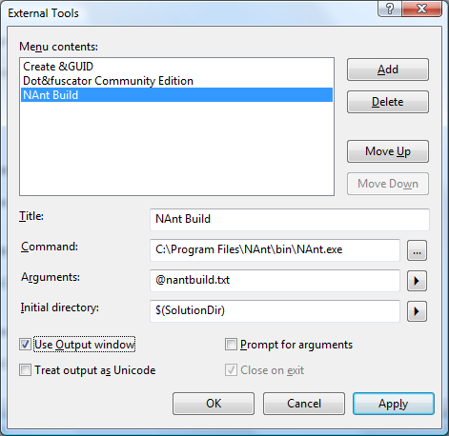

- You will now find an NAnt Build item under the Tools menu.

